Enthalpy Tune Up

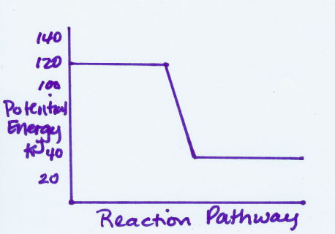

1. Answer the questions regarding the graph at the right.
- What is the heat of the reaction?
- Is the reaction endothermic or exothermic?
c. Label the reactants and the products.
d. Which is more stable, reactants or products?
e. What is the sign of ΔH?

2 A 5.00-g sample of liquid water at 25.0 C is heated by the addition of 84.0 J of energy. The final temperature of the water is __________ °C. The specific heat capacity of liquid water is 4.18 J/g-K

A) 95.2
B) 25.2
C) -21.0
D) 29.0
E) 4.02

3. Sn(s) + Cl₂ (g) → SnCl₂(s) ΔH =-352 KJ

SnCl₂(s) + Cl₂(g) → SnCl₄ (l) ΔH = -186 KJ

Calculate ΔH for the following reaction:

Sn(s) + 2Cl₂(g) → SnCl₄

4. 2CO(g) +O₂ (g) → 2CO₂(g) ΔH = -586.0 KJ

N₂(g) + O₂ (g) → 2NO (g) ΔH = 180.6 KJ

Calculate ΔH for the following reaction:

2CO(g) + 2NO(g) → 2CO₂ (g) + N₂(g)

5. Liquid water turns to ice. Is this process endothermic or exothermic? Explain what is occurring using the terms system, surroundings, kinetic energy and potential energy.

6. Determine the ΔH for the following reaction using bond energies.
- The bond energy of the H-O bond is 110 kcal.
- The bond energy of H-H bonds is 103 kcal.
- The bond energy of the O=O bonds is 116 kcal.
2H₂O → 2H₂ + O₂

